TSTool Quick Start Guide

2014-02-24

This document will help you download, install, and start TSTool, and will point out other resources that are available for more in-depth learning. This guide assumes very little experience. After reading the guide and trying some of the examples, you will have a basic understanding of how TSTool works, and can begin to explore its capabilities. This document focuses on installing TSTool on Microsoft Windows; however, the information is relevant for Linux and Mac computers.

TSTool (“time series tool”) was originally developed for the State of Colorado as part of Colorado’s Decision Support Systems (CDSS) in order to process data from the State’s HydroBase database into data files for river basin models. Since that time, TSTool has been enhanced to have many capabilities, as described below can be applied to many problems involving time series, databases, maps, and websites. TSTool has been developed and enhanced with funding from the State of Colorado and others sources and the State is migrating TSTool and other CDSS software to open source licensing. Currently, the Open Water Foundation (OWF) continues to enhance and support TSTool in support of various projects.

# TSTool Capabilities

TSTool, as the name implies, focuses on processing time series. Time series are data constructs that include date/time and value pairs, for example to indicate how temperature, precipitation, and streamflow change over time. Time series can be represented in tabular and graphical form, as shown below.

|  |  |
| --- | --- |
|  |  |

TSTool provides a graphical user interface that allows users to query and interact with data. However, at its core, TSTool is intended to be a workflow automation tool, meaning that it encourages users to define data processes as a repeatable sequence of commands. The focus on automation generally means that a user may spend more time up front thinking through the logic of data processing, but once defined, this process can be repeatedly run, scaled to process more data, and enhanced as refinements to the process are needed. In comparison, TSTool implements a sequential command workflow that keeps data and logic separate, whereas spreadsheet tools like Microsoft Excel tend to merge data and processing.

TSTool commands are able read, manipulate, visualize, and output time series. Manipulation includes basic actions such as adding, subtracting, and multiplying time series; filling missing data values; calculating statistics from time series; converting time series into different formats; and many other capabilities.

TSTool is able to read data from common databases, file formats, and web services, and additional formats are supported as the software is enhanced. Web services allow software to access data in standard formats using the internet. Data from web services are used in examples in this document so that the basic software install can be used.

# Download TSTool

TSTool is available on the CDSS website (http://cdss.state.co.us/software/Pages/TSTool.aspx). This version is “frozen” at the version that is used by the State for its projects. This version also is distributed with the HydroBase DVD, which is available for a fee from the Colorado Division of Water Resources.

Additionally, an archive of TSTool versions is available on a website maintained by the OWF (<https://sites.google.com/site/cdssstaging/tstool/download>). Older versions may be needed to match an earlier analysis and newer versions provide access to new features that may not yet be needed for State CDSS projects.

See the release notes for each version to determine which features might be useful.

# Install TSTool

The websites indicated in the previous section provide access to TSTool software installers, which for Windows have names similar to TSTool_CDSS_10.27.00_Setup.exe. Save the installer on the computer and then run the installer. You do not need to be administrator to install TSTool; however, installing as administrator will ensure that the uninstaller works properly in Windows.

It is recommended that you select all the defaults for the installer. TSTool will install to a versioned folder so that multiple versions can be installed at the same time. The files install to C:\CDSS\TSTool-Version and a start menu is created: All Programs… CDSS… TSTool-Version. In both cases the version is something like 10.27.00.

TSTool installers for Linux are available for some versions and Linux and Mac installers will be more accessible in the future as resources are put towards testing on these operating systems.

# Start TSTool

TSTool can be started using the Start… All Programs… CDSS… TSTool-Version menu. At startup TSTool attempts to make a number of connections to databases and web services and will display a message similar to the following figure (below left). Because TSTool is distributed for use with the State of Colorado’s HydroBase database, the following login window will be displayed (below right):

|  |  |
| --- | --- |
|  |  |

Unless you have been provided with a HydroBase DVD or have access to HydroBase on a server, you will not be able to select a HydroBase database. Consequently, press Cancel and HydroBase features will be disabled.

To disable the HydroBase login, select the Tools…Options menu, select the Enabled Input Types tab and uncheck the HydroBaseEnabled checkbox. Restarting TSTool will then not display the Select HydoBase dialog.

# Example 1 – Data Browsing and Viewing

After TSTool has finished initializing data connections, the upper part of the main window can be used to browse time series data. The following figure illustrates the top part of the window after query options have been specified and Get Time Series List has been pressed to query time series.

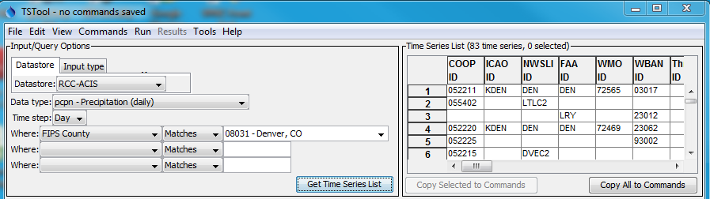

To query time series, first select a Datastore or Input type. Datastores connect to databases and web services. Input types generally access files, such as simple time series data formats or model files. The selection is used only for interactive browsing. In actuality, TSTool has multiple data connections active from start-up that can be used with commands as described in the next section (you can view active datastores using View…Datastores).

Once a datastore or input type is selected, other choices are made available as appropriate to help filter the time series list. For example, in the above figure, the Regional Climate Center Applied Climate Information System (RCC ACIS) datastore is selected, and daily precipitation is selected. Denver County is selected to limit the number of stations that are returned. Pressing Get Time Series List queries the web service and lists the time series in the upper right of the main TSTool window, as shown in the above figure. The query does not process all the time series data values but only the location (typically stations) and time series metadata (available period of record, data units, etc.). Use the scroll bar to review all available metadata. Right-click on the column headings to sort the columns. In general, right-clicking in TSTool shows available actions.

To query the time series data values, first select one or more of the time series by highlighting cells in the time series list. Use CTRL-click to select an additional cell and SHIFT-click to select a range. The numbered column cannot be selected. When one or more cells of interest are selected, press Copy Selected to Commands. If the first two rows in the above figure are selected, the following will be shown in Commands area (middle) of the TSTool main window:

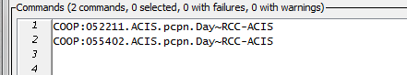

Whereas the top of the TSTool main window is used to browse data, the Commands area is used to define a workflow of commands, to automate data processing. Command processing is similar to using functions in Excel; however, in TSTool the processing logic presented in visible text form like a script, processing is sequential (first command to last), and processing logic is separate from data. In TSTool data are maintained in the program’s memory and are accessed by identifiers as needed.

When time series are selected in the upper-right area of the main TSTool window and are copied to the Commands area, the time series are represented as a time series identifier (TSID), which is a unique identifier that allows TSTool to read the time series. The general form of a TSID is:

Location.DataSource.DataType.Interval~DataStoreOrInputType

The periods in this identifier are important because they indicate the separation between TSID parts. The TSID generally is consistent throughout TSTool but is impacted by the specifics of each data source. For example, the United States Geological Survey (USGS) National Water Information System (NWIS) web service uses a data type of 00060 to indicate stream discharge whereas other datastores use text datatype. In general, users need to understand the source, characteristics, and limitations of data because there is not a “magic data button”.

To read the data for the indicated TSID, press the Run All Commands button. In this example, TSTool will request data from the RCC ACIS web service. Progress in processing commands and progress within each command is indicated in the lower right corner of the main window. When progress is 100% complete, time series that are read are listed in the Results area in the main window. To view the time series graphically, right-click on the time series list and select the Graph – Line menu. This will result in a general graphing tool being displayed. You can page through data by using the navigation buttons under the graph. You can also zoom into a period by drawing a box on the main graph or the overview graph using the mouse. View the time series in a table by selecting the Table button.

Up to this point you have been exposed to a few TSTool conventions such as TSIDs and have a basic idea about the mechanics of using the interface. However, the real power of TSTool is in its ability to automate data processing.

# Example 2 – Command Example

Interactively browsing through data is a useful capability and is often the way that one would start evaluating how to perform a data analysis. However, repetitively “clickity-clicking” on menus and buttons is not efficient when you have a lot of work to get done, and trying to remember a sequence of manual steps can lead to errors and inefficiency. Consequently, TSTool provides commands to automate processing. Commands are somewhat equivalent to Excel spreadsheet formulas; however, TSTool commands are configured in the command area rather than being mixed with data.

TSTool by default tries to query as much information as possible because a data user typically does not know what is available. Once the amount of data is known, the user can evaluate data quality and filter to their needs. The TSID notation in the Commands area tells TSTool to read the time series. However, there are no controls to indicate the period to read or provide other options that may be available for the datastore. To illustrate how commands are useful, first select one of the TSIDs in the Commands area (by left-clicking). Then right-click to display the popup menu and select the Convert TSID command to general ReadTimeSeries() command menu. This will convert the TSID into ReadTimeSeriesCommand() as shown in the first command in the following figure:



The syntax for commands is CommandName(ParameterName=ParameterValue,…). Uppercase/lowercase is generally ignored but TSTool uses mixed case to make commands and parameters more readable. Unlike Excel formulas, command parameters can be in any order because the parameter name is provided.

To edit the first command, double-click on it or select, right-click, and select Edit from the pop-up menu. The command editor will be similar to that shown in the following figure.

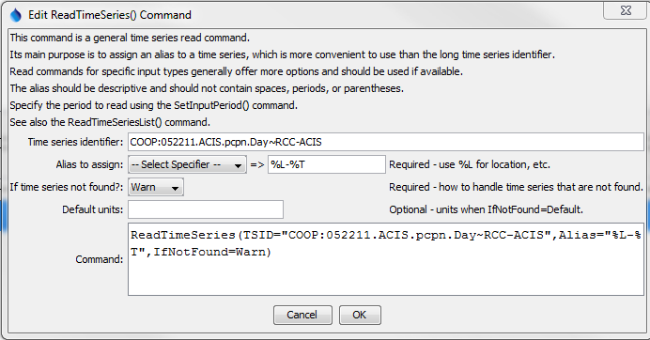

Command editors provide a brief explanation and edit fields for command parameters. The notes to the right of each entry field indicate whether a parameter is required or optional. As much as possible TSTool tries to provide choices. This can be difficult for dynamic data such as time series that are read during processing. Consequently, TSTool partially runs commands during editing to provide information, and this is why sometimes there is a delay after inserting TSIDs or commands in the Commands area.

In the above example, the Alias parameter has been specified to provide an alternative way to refer to the time series because TSIDs can be long. After pressing OK to save the edits to the command, press Run All Commands in the main TSTool window to process the commands again. The time series listed in the results area will then show the alias for the time series. This alias is displayed in choices when other commands are edited.

# Example 3 – Visualization Example

# Doing More with TSTool

# Resources

This page is intentionally blank

.